Task P – 2 c

Fuzzy logic

Saurabh Dharmadhikari

Saurabh.dharma01@gmail.com

Fuzzy logic in restaurants

Introduction:

Fuzzy logic technology has been used to solve a variety of problems in many domains. One such domain where fuzzy logic technology can be used is the restaurant industry. By using fuzzy logic, an automatic train operation system can be developed for the restaurant domain that can automate several tasks such as food preparation, ordering, and delivery and also sale prediction. In this report, we will outline the application of fuzzy technology in the restaurant domain and how it can be used to predict sales in a restaurant.

The restaurant domain sale prediction was done by the mangers or industry experts classically, many new ML based prediction models are being used now a days to have even more accurate predictions of sales in a restaurant as they have shown to be more effective than classical methods and they also reduce the time and efforts taken to get these accurate predictions. Sale prediction is important for restaurants as with the help of predictions they can control their cost by scheduling the employees and also keeping the stock of pre cooked products in check and ordering raw materials.

ML in sale prediction in restaurants:

* Case study on medium sized restaurants shows that the best results seen in one-day forecasting come from linear models with a sMAPE of only 19.6%. Two RNN models, LSTM and TFT, and ensemble models also performed well with errors less than 20%. When forecasting one-week, non-RNN models performed poorly, giving results worse than 20% error. RNN models extended better with good sMAPE scores giving 19.5% in the best result. The RNN models performed worse overall on datasets with trend and seasonality removed, however many simpler ML models performed well when linearly separating each training instance. **(Schmidt Austin, MdWasi Ul Kabir, Md Tamjidul Hoque, ResearchGate, 2020, p. 2)**

**ML Work flow:**

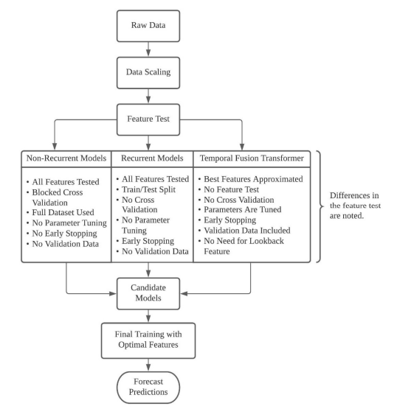

**Figure 1: (Schmidt Austin, MdWasi Ul Kabir, Md Tamjidul Hoque, (ResearchGate) 2020, p. 14)**

Above image shows the work flow to deploy models in this study to make predictions for the sales of a restaurant.

Machine learning models show very promising results with one day testing, and future studies on extending the forecasting window could be beneficial, as linear models are fast and simple to train. Ridge may be useful in providing one-step predictions to be used as some stepwise prediction in a longer forecast window. Similarly, as ensemble methods provided good results, it may be worth allowing linear models to predict single-step sequences of daily differences in sales for use as feature labels when training and forecasting TFT models. **(Schmidt Austin, MdWasi Ul Kabir, Md Tamjidul Hoque, (ResearchGate) 2020, p. 125)**

Fuzzy Logic for Predicting sales:

A study on fuzzy logic-based approach on sale prediction for garment industry done by Bangladesh university of textiles presented in Proceedings of the International Conference on Industrial Engineering and Operations Management Dubai, UAE, March 10-12, 2020 says Gardner and McKenzie in 1988 tried to guide in identifying exponential smoothing models with non-seasonal data in Fuzzy rule extraction directly from numerical data for function approximation. They highly recommended to select the models at first where exponentially smoothing model will show a better result without applying it everywhere. D. W. Cho and Y. H. Lee in 2013 considered seasonal factors that affect the demand of a product which causes a highly fluctuating situation in the supply chain. Roberts worked on formulating short term sales forecasting and introduced a range of Fuzzy models of considerable importance. He suggested using simple combined forecasting models with more accuracy as benchmark rather than a complex combination.Claudio S. Bisso and Carlos Patricio Samanez used Fuzzy Logic approach for determining the distribution of a particular item and model developed by considering the alternatives. R.J. Kuo and K.C. Xue in 1998 attempted to develop an intelligent sales forecasting system using Fuzzy Sets, Fuzzy Logic, and Fuzzy Systems which pointed far improved result than conventional autoregressive moving average (ARMA) method. They also supported the suitability of their combined Fuzzy Artificial Neural Network (FANN) model comparing with single ANN method. R.J. Kuo developed GFNN (a fuzzy neural network model with initial weight developed from genetic algorithm) to forecast sales of a convenience store (CVS) company which showed reasonably better outcome in case of fluctuating internal and external environments like special offers, promotion, etc. **(Rashid, M. M., Khan, M. R. and Ghosh, S. K. (2020, p. 1)**

Thus, fuzzy logic shows better results in predicting sales taking in account seasonality and many other factors that guide sale. We know that restaurant sales have seasonality and fuzzy logic solutions can help better at predicting sales for a restaurant.

Steps in developing fuzzy logic:

1. Define the problem:

The first step in developing a decision-making system using fuzzy technology is to define the problem. In the restaurant domain, the problem is to predict sale.

1. Define the input variables:

The next step is to define the input variables. In the restaurant domain, the input variables can be historical data, customer preferences, and other sensors such as GPS and traffic sensors.

1. Define the output variables:

The next step is to define the output variables. It is sale prediction for the restaurant, also, sale can be predicted on hourly bases, number of employees required, pre-production required for a day.

1. Define the fuzzy sets:

The next step is to define the fuzzy sets. Fuzzy sets are used to represent the uncertainty and imprecision in the input variables. The fuzzy sets can be defined using linguistic terms such as "hot," "cold," "fast," and "slow."

1. Define the fuzzy rules: This will include rule given to the machine by the experts. Machine will run its algorithms and will find near to optimum.



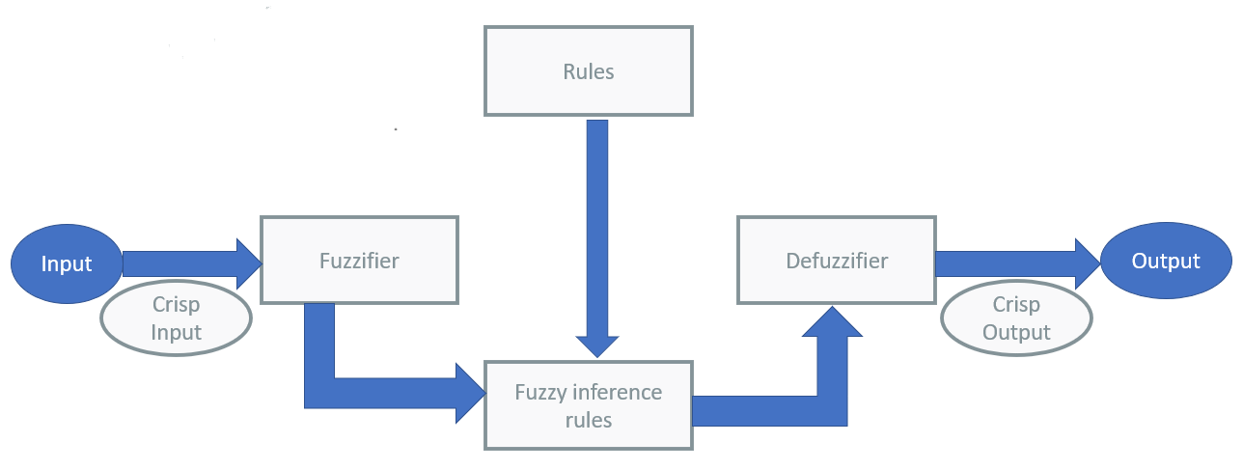

The above diagram shows the basic structure of how fuzzy logic will work for predicting values.

Conclusion:

Studies in different shows that fuzzy logic solution work very well with predictions on sale in different industries and domains. Thus, fuzzy logic can give us very good results at predicting sales for restaurants as it takes in different inputs such as seasonality into consideration and give us accurate predictions.

**References**

Researchgate.net. (January 2020) Machine Learning Based Restaurant Sales Forecasting (Accessed: April 6, 2023). Available at: https://www.researchgate.net/publication/358233577_Machine_Learning_Based_Restaurant_Sales_Forecasting

scholar.google.com. (n.d.) (2020). A Fuzzy Logic Based Approach towards Sales Forecasting: Case Study of Knit Garments Industry. [online] [Accessed 6 Apr. 2023]. Available at: https://scholar.google.com/citations?view_op=view_citation&hl=en&user=tpzeG8gAAAAJ&citation_for_view=tpzeG8gAAAAJ:9yKSN-GCB0IC

**List of figures**

|  |  |
| --- | --- |
| Figure 1 | Researchgate.net. (January 2020) Machine Learning Based Restaurant Sales  Forecasting (Accessed: April 6, 2023). Available at: <https://www.researchgate.net/publication/358233577_Machine_Learning_Based_Restaurant_Sales_Forecasting> |